**CS590-BigData Analytics and Apps – (Summer 2014)**

**Lab 1: Report**

**Cloudera Installation**

**and**

**MapReduce application "Word Count"**

**Submitted By :**

**Gireshbabu Yemparala**

**16137268**

**Subtask 1 : How to access UMKC Cloudera Servers**

1. Download and Istalled the VPN for umkc, and connect it with the UMKC sso,
2. Go to the link
3. <http://134.193.136.147:7180/cmf/login>
4. 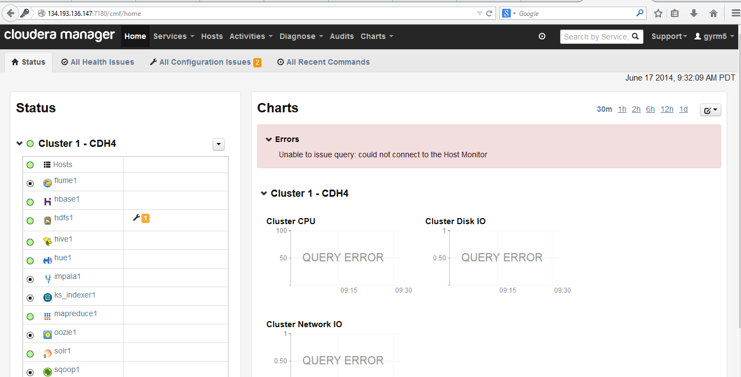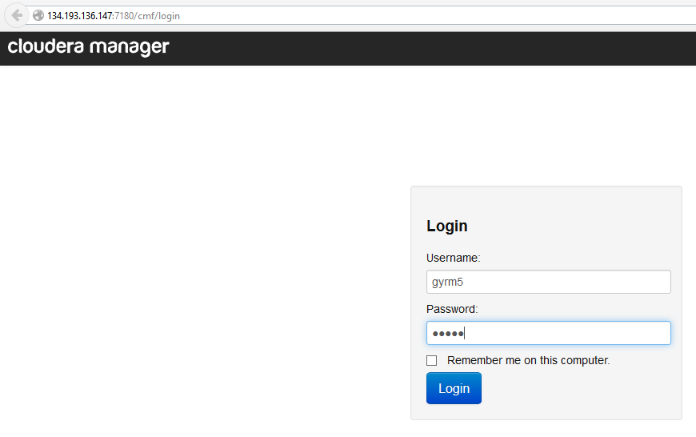

**Subtask 2 : Install your own cloudera server**

**Step1:**

First, setup a Virtual Machine on your local PC like (Virtual Box / VMWare)

( I, used VMPlayer)

Visit the VMPlayer website and Download It <https://my.vmware.com/web/vmware/free#desktop_end_user_computing/vmware_player/6_0> )

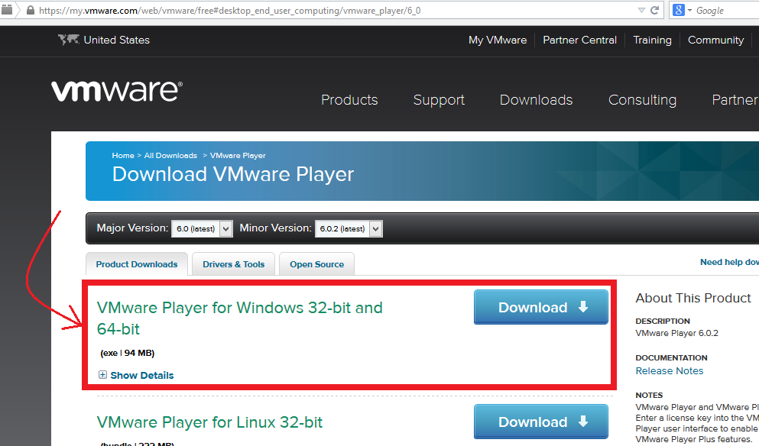

– Download and Install VMPlayer in the PC

-After the Above step visit the Cloudera Website to download the appliance from the below link

<http://www.cloudera.com/content/support/en/downloads/quickstart_vms/cdh-5-0-x.html>

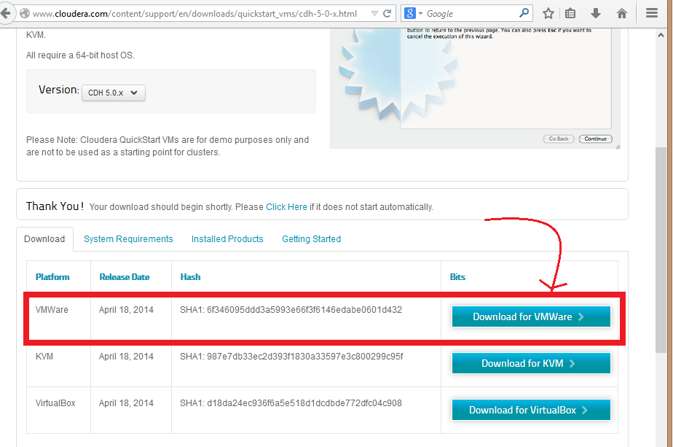Download and UnZip the file and open in the VMPlayer

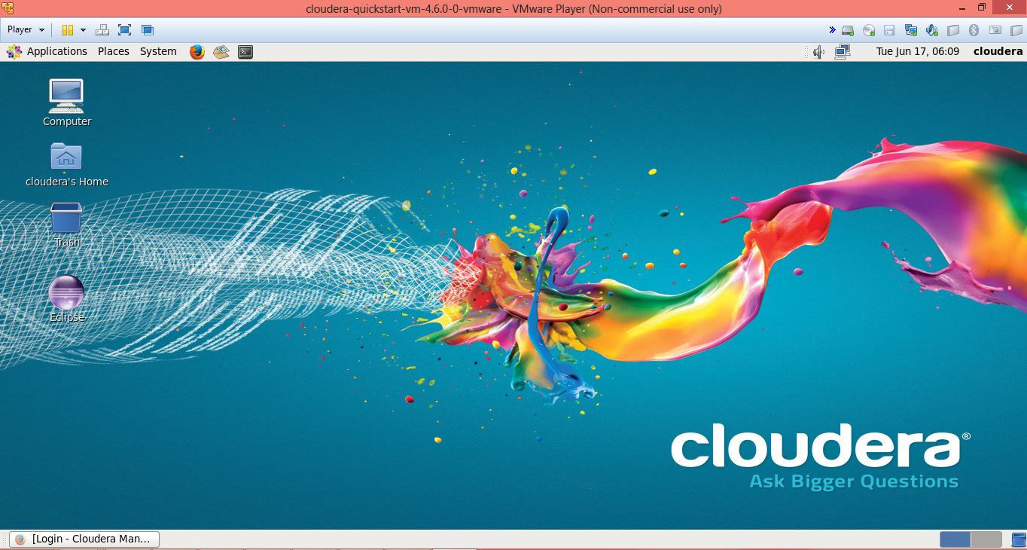

Subtask 3: Transfer files to cloudera

1 initially after loginig into cloudera by putty

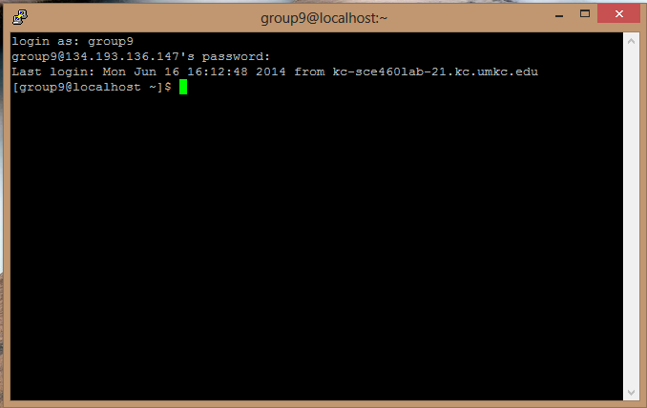

Login to the cloudera by Winscp

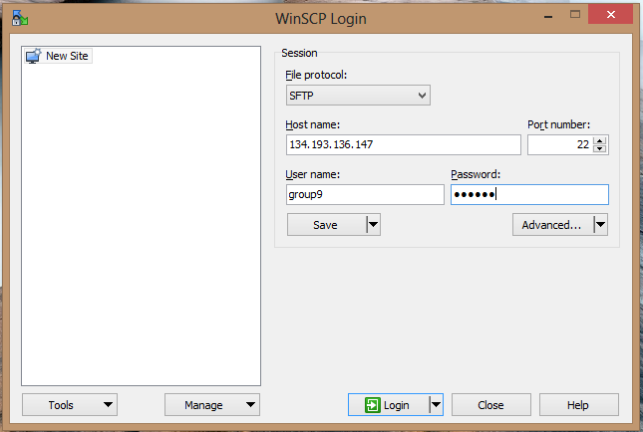

Winscp Interface

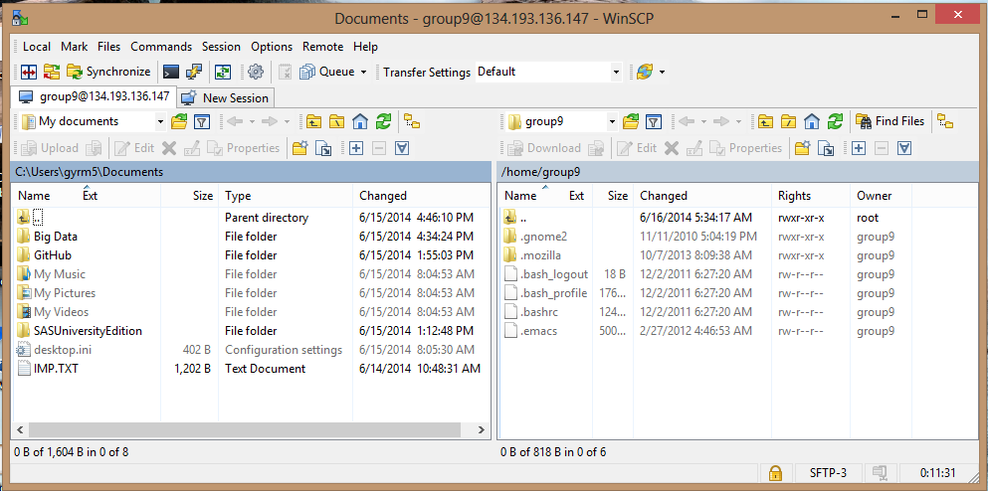

Download the word count file and drag to the local folder of winscp

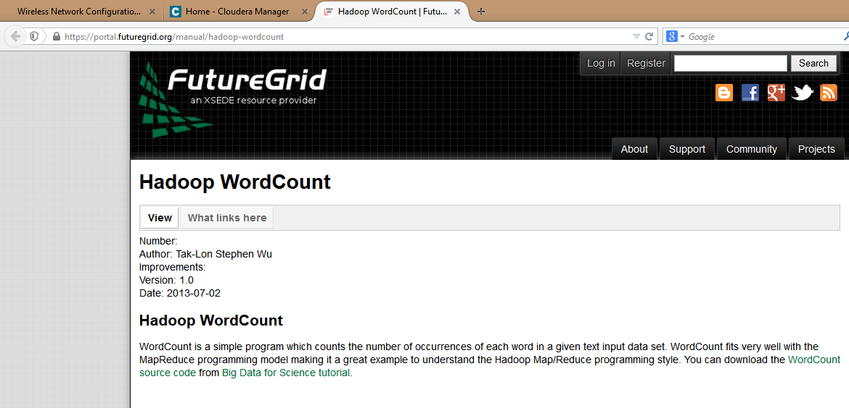

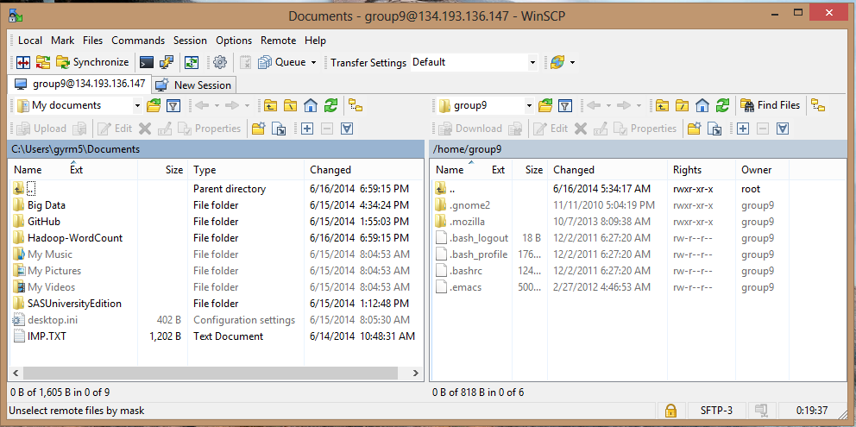

Then upload the file to home group

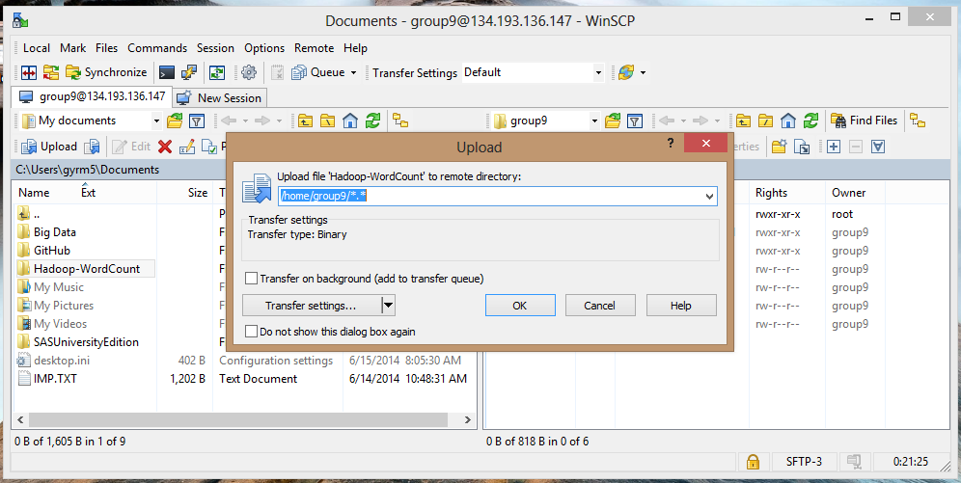

Now u can see the file in cloudera

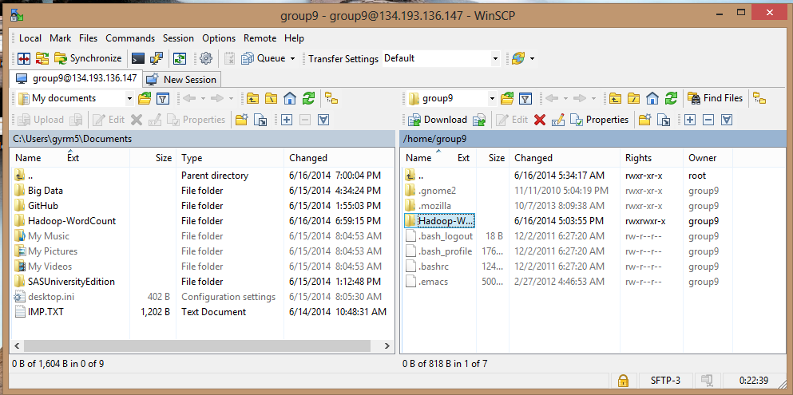

Check the file with putty

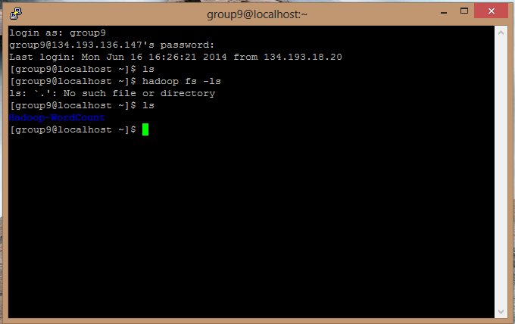

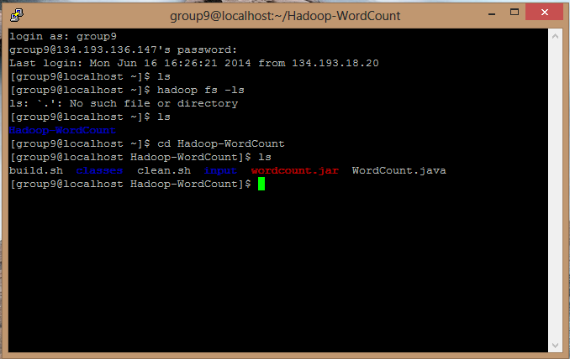

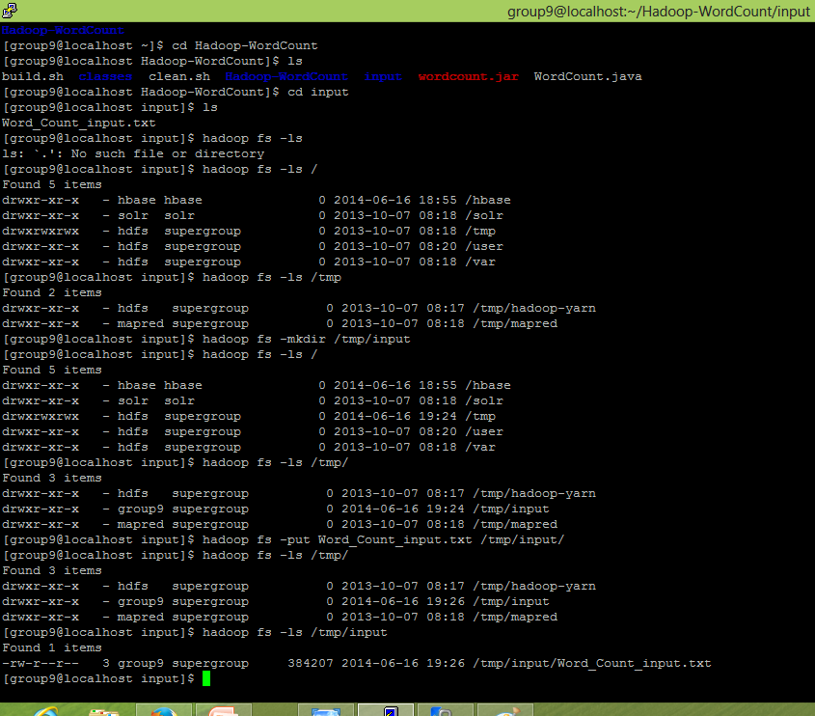

Our group dint have the permission to write the jar file to hadoop where we encountered an error